- Is JavaScript asynchronous or Synchronous by nature?
  - JavaScript is synchronous and single-threaded, meaning it runs code one step at a time.
  - It can handle asynchronous tasks (like API calls) without blocking the main process.
- How does JS handle its asynchronous nature?
  - This can be done using: Callbacks, Promises, Async/await
- Event Loop: (Call Stack, Web APIs, Callback Queues)
- The 3 main components of event loop
- Call Stack: Executes synchronous code, One function at a time (LIFO)
- Web APIs / Background APIs: Handle async operations,
  - Examples: setTimeout, DOM events, HTTP requests
- Callback Queue: Store callbacks ready to be executed after async tasks complete
  - Microtask Queue: Promise.then, queueMicrotask, MutationObserver
  - Macrotask (Callback) Queue: setTimeout, setInterval, I/O, UI event
Event Loop execution
  - The event loop is a mechanism that allows JavaScript to handle asynchronous operations without blocking the main thread.
  - It monitors the call stack and the callback queue and web APIs,
    - Execute all synchronous code in the call stack until it becomes empty
    - when the call stack is empty,
      - Then it run all microtasks
      - Then it run one microtask
    - And repeat the execution forever.

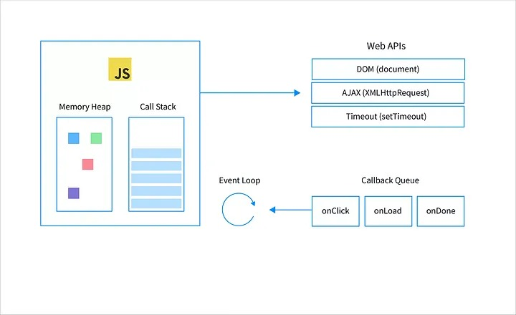

- Explain callbacks, promises and async await with examples. How these concepts utilized in automation tools?
  - Callbacks: Cypress internally manages asynchronous tasks with promises, so you don't need to deal with explicit callbacks. cy.get(), cy.type(), cy.click(),
  - Promises: Cypress commands like cy.visit(), cy.get(), cy.type(), cy.click(), and cy.url()etc., are built on promises, which handle waiting for actions to complete and chaining operations together.
  - Async/Await: Cypress itself doesn’t require async/await for its commands. However, async/await can be used for handling non-Cypress asynchronous tasks (such as API calls) in your tests. cy.get(), cy.click()
SrNo | Method | Function | Returns | Use Case in Automation
1 | length | Gets array size | Number | Counting elements on a page
2 | push() | Adds to end | New length | Storing test results
3 | unshift() | Adds to start | New length | Prioritizing test cases
4 | pop() | Removes last element | Removed element | Removing last test case
5 | shift() | Removes first element | Removed element | Processing test queues
6 | splice(startIndex, deleteCount) | Modifies at index | Removed elements | Removing test cases dynamically
7 | concat() | Merges arrays | New array | Combining test suites
8 | slice(start,notEnclusiveEnd) | Extracts portion | New array | Running subset of tests
9 | join() | Converts to string | String | Formatting test reports
10 | sort() | Sorts elements | Sorted array | Organizing test cases
11 | reverse() | Reverses array | Reversed array | Changing execution order

- Explain object methods to add data to Objects.
  - object.key = value
  - Adds a property using dot notation
  - Use case: Adding static test attributes
let testResult = {};
testResult.testName = "Login Test";
testResult.status = "Passed";
console.log(testResult);
// { testName: "Login Test", status: "Passed" }

- What are the differences between var, let and const variables? Provide examples demonstrating proper usage in test scripts.
  - ✅ Use const for test data that does not change (URLs, element locators).
  - ✅ Use let for dynamic variables (element counts, test results).
  - ❌ Avoid var due to its function-scoping and hoisting behavior.
- Describe the difference between null and undefined in JS. How do these differences impact test validation?
  - undefined
    - If an element’s attribute is undefined, it may not exist in the DOM.
    - Use proper null/undefined checks in assertions to avoid errors.
  - null
    - If an API response returns null, it means the value was intentionally cleared.
    - Helps in asserting empty fields in forms or responses.
- Explain the key concepts of Object Oriented Programming(OOP) in JavaScript. Please provide the examples of where you used OOP in your cypress automation frameworks.
OOP Concept | Used in Cypress? | Example
Encapsulation | Yes | Page Object Model (POM) for web elements & actions
Abstraction | Yes | BasePage class to hide Cypress commands
Inheritance | Yes | Extending BaseTest for setup & utilities
Polymorphism | Yes | Overriding visit() method for different pages

- Which JavaScript based automation tools you have worked?
Feature / Tool | Selenium (JS) | Cypress | Playwright | WebdriverIO
Type | Web Automation (UI) | E2E Testing (UI) | E2E + Cross-Browser | Web & Mobile Testing
Language | JavaScript (via WebDriverJS) | JavaScript / TypeScript | JavaScript / TypeScript | JavaScript / TypeScript
Browser Support | All major browsers | Chromium only (headless/headed) | Chromium, Firefox, WebKit | Chrome, Firefox, Safari, Edge, IE
Mobile Testing | ✅ (via Appium) | ❌ | ✅ (via device emulation) | ✅ (with Appium)
Test Speed | 🐢 Slower (due to Selenium Grid) | ⚡ Very Fast | ⚡ Fast | Moderate
Auto Wait Handling | ❌ | ✅ Built-in | ✅ Built-in | ❌ (manual waits needed)
Parallel Execution | ✅ | ✅ (via CI plugins) | ✅ Built-in | ✅
Cross-Platform | ✅ | ✅ | ✅ | ✅
API Testing | ❌ | ✅ (using cy.request) | ✅ (via fetch/axios) | ✅
UI Snapshot/Tracing | ❌ | ✅ (basic screenshots) | ✅ (video, trace viewer) | ✅ (with plugins)
Best For | Legacy Cross-browser UI | Frontend E2E | Cross-browser E2E | Web + Mobile Combo

- Describe how you achieve cross browser testing ?Provide examples based on the tools you have used
- Used Cypress As Test Automation Tool
- To achieve cross browser testing, We used chromium based browser like Chrome, Edge, Firefox, Firefox Nightly
- Discuss the type of locators and which locator you use for UI automation scripts
- • ID Selector (#id)
- • Class Selector (.class)
- • Tag Name Selector (element)
- • Attribute Selector ([attr=value])
- • Combination Selectors
- • Text Selector
- • XPath (via plugin)
- How do you test responsiveness for web pages?
  - Manually test different screen sizes using Chrome DevTools (Toggle Device Toolbar).
  - Emulate different viewport sizes in Cypress using cy.viewport():

- Write a sample code for API testing, demonstrating any HTTP request and validate the response
- describe('API Testing', () => {
- it('GET Request', () => {
- cy.request({
- method: "GET",
- url: 'https://jsonplaceholder.typicode.com/posts/1'
- }).its('status')
- .should('equal', 200);
- })

- it('POST Request', () => {
- cy.request({
- method: "POST",
- url: "https://jsonplaceholder.typicode.com/posts",
- body: {
- "userId": 1,
- "title": "POST Request Title",
- "body": "POST Request Body"
- }
- }).its('status').should('eq', 201)
- })

- it('PUT Request', () => {
- cy.request({
- method: "PUT",
- url: "https://jsonplaceholder.typicode.com/posts/1",
- body: {
- "id": 1,
- "userId": 1,
- "title": "PUT Request Title",
- "body": "PUT Request Body"
- }
- }).its('status').should('eq', 200)
- })

- it('DELETE Request', () => {
- cy.request({
- method: "DELETE",
- url: "https://jsonplaceholder.typicode.com/posts/1"
- }).its('status').should('eq', 200)
- })
- })

- Custom commands in Cypress
  - Cypress.Commands.add('getIframe', (iframe) => {
  - return cy.get(iframe).its('0.contentDocument.body').should('be.visible').then(cy.wrap);
  - })

  - Cypress.Commands.add('clickLink', ((label) => {
  - cy.get('a').contains(label).click();
  - }))

  - Cypress.Commands.add('LoginToApp', (username, password) => {
  - cy.get('input[placeholder="Username"]').type(username);
  - cy.get('input[type="password"]').type(password);
  - cy.get('button[type="submit"').click()
  - })

- How you handle iFrames in web pages
- ///<reference types="cypress-iframe" />
- // iframe: An inline frame (iframe) is a HTML element that loads another HTML page within the document
- // NOT WORKING on website
- describe('Handling iframe', () => {
- it('iframe handling using its() method', () => {
- cy.visit('https://the-internet.herokuapp.com/frames');
- cy.get('[href="/iframe"]').click();

- const iframe = cy.get('#mce_0_ifr').its('0.contentDocument.body').should('be.visible').then(cy.wrap);
- iframe.clear().type('Writing description using cypress automation {ctrl+a}');
- cy.get('[aria-label="Bold"').click();
- cy.get('[aria-label="Italic"').click();
- })

- it('iframe handling using custom command', () => {
- cy.visit('https://the-internet.herokuapp.com/frames');
- cy.get('[href="/iframe"]').click();

- cy.getIframe('#mce_0_ifr').clear().type('Writing iframe description using custom command {ctrl+a}');
- cy.get('[aria-label="Bold"').click();
- cy.get('[aria-label="Italic"').click();

- })

- it('iframe handling using cypress-iframe plugin', () => {
- cy.visit('https://the-internet.herokuapp.com/frames');
- cy.get('[href="/iframe"]').click();

- cy.frameLoaded('#mce_0_ifr'); // load iframe
- //interact with iframe
- cy.iframe('#mce_0_ifr').clear().type('Writing iframe description using cypres-iframe plugin {ctrl+a}');
- })
- })

- Explain how to handle multiple tabs while automating
  - Cypress does not support multiple browser tabs or windows directly, due to its architectural design which is based on running everything within a single browser tab. However, you can handle multiple tab scenarios using workarounds.
  - . Intercept target="_blank" links and force them to open in the same tab
- Performance and load testing approaches
Tool | Type | Description
JMeter | Load & Performance | Open-source, highly customizable
Lighthouse | Frontend performance | Chrome-based tool for web apps

- Difference in Scenario and Scenario outline
Feature | Scenario | Scenario Outline
Purpose | Used to test one specific case | Used to run the same scenario with multiple sets of data
Data parameterization | ❌ Not parameterized | ✅ Parameterized using <placeholders>
Keyword used | Scenario | Scenario Outline + Examples block

- Difference between Examples and Data Table
Feature | Examples keyword | Data Table
Used with | Scenario Outline | Scenario
Purpose | To provide multiple sets of data | To pass structured tabular data
Structure | Works with <placeholders> | Passed as a table within the step itself

- Tags and Hooks in Cucumber
  - Used to group, include, or exclude scenarios.
  - Hooks are blocks of code that run before or after scenarios.
- Explain Page Object Model(POM) and provide a sample code snippet demonstrating the same
  - Page Object Model (POM) is a design pattern in test automation where you create separate classes for each web page, encapsulating locators and actions related to that page.
  - It helps make test code more clean, reusable, and maintainable.
- Describe how you manage data within your framework
  - Managing test data effectively is crucial in automation frameworks to ensure maintainability, reusability, and scalability.
  - JSON File (fixture)
  - Environment Variables (cypress.env.json)
  - Custom Commands
  - Random Data Generation using faker.js, uuid type
- Describe different design pattern and how you implemented those in framework
  - Page Object Model : Separates test logic from the page-specific locators and actions.
- Explain how OOP concepts are applied in your test framework
  - Encapsulation: Keeping locators and action methods that operate on them bundled together in one unit (class or module).
  - Inheritance: Reusing code by creating child classes that inherit behavior from parent classes ex: baseClass & parentClass OR customCommands in cypress
  - Abstraction: Hiding complex implementation details and exposing only what is necessary.
  - Polymorphism: Objects can take on many forms — same method name, different behavior depending on the object

- Different components of your automation framework
  - Test Scripts / Specs: These are actual test cases written in a human-readable format.
  - Page Object Model (POM): Encapsulates locators and reusable actions for specific pages or components.
  - Locators or Selectors Layer: Centralizes all UI element selectors to avoid duplication and make maintenance easier.
  - Utilities / Helpers: Common utilities like random data generation, wait logic, custom commands, etc.
  - Test Data Management: Can be static (JSON files), dynamic (faker.js), or fetched from DB/API.
  - Assertions / Validations: Use assertion libraries like chai or built-in Cypress assertions.
  - Configuration Management: Includes environment-specific configurations like URLs, tokens, DB connections, etc.
  - Reporting: Generates test execution reports using tools like:
    - Mochawesome
    - Allure
  - CI/CD Integration: integrates with tools like Jenkins, Bitbucket Pipelines
  - Logging & Screenshots: Automatic screenshot capture on test failure.
  - Custom Commands: Use to add reusable logic.
  - Error Handling & Retry Logic: Smart retry for flaky steps (built-in in Cypress).

- Best practices and SOLID principles followed in the framework?
  - Use Page Object Model (POM):
    - Keeps locators and actions in separate classes/modules.
    - Promotes reusability and maintainability.
  - Keep Tests Independent:
    - Tests should not rely on the outcome of other tests.
  - Clear Naming Conventions:
    - Methods, variables, and files should have meaningful names.
  - Use Custom Commands/Helpers:
    - Avoid repeating common sequences by abstracting them.
  - Centralized Configuration:
    - Keep URLs, credentials, and timeouts in config files.
  - Proper Logging and Reporting:
    - Integrate tools like Allure, Mochawesome for insights.
  - Data-Driven Testing:
    - Use external files (JSON, CSV, Excel) for test data.
  - Environment Separation:
    - Use different configurations for dev, QA, staging, prod.
  - Handle Waits Properly:
    - Prefer implicit or smart waits (like cy.intercept) over static waits.
  - Error Handling and Recovery:
    - Use hooks and exception handlers to manage flaky scenarios.
- Provide strategies to minimize the flakiness in test scripts
  - Avoid Hard Waits
  - Use Robust Selectors
  - Ensure Elements Are Ready
  - Clean Up State Before/After Tests
  - Isolate Test Cases
  - Use Retry-ability (Cypress/Playwright feature)
  - Disable Animations (if needed)
    - Animations can cause timing issues.
    - Disable via app settings or CSS override during testing.
  - Parallelization and Environment Isolation
    - Run tests in parallel using CI runners.
    - Avoid shared environments or test data clashes.
  - Add Logging & Screenshots
- Can you describe the difference between authentication and authorization?
  - Authentication Purpose: To verify the identity of a user or system.
  - Authorization Purpose: To determine what access or permissions a user has after authentication.

Playwright Interview Questions
- What is Playwright?
- Playwright is an open-source end-to-end automation framework developed by Microsoft that enables reliable cross-browser testing for modern web applications using a single API.
- Why Playwright over Selenium?
- No WebDriver dependency
- Built-in auto-waiting
- Native parallel execution
- Browser context isolation
- Faster execution
- Built-in API testing
- It provides better stability and modern web support compared to Selenium.
- Which browsers does Playwright support?
- Chromium
- Firefox
- WebKit (Safari engine)
- What is auto-waiting in Playwright?
- Playwright automatically waits Before performing any action for elements to be:
- Attached to DOM
- Visible
- Stable
- Enabled
- Difference between page and browserContext, newContext, newPage, Worker, Project?
- browserContext → isolated browser session
- page → single tab inside context
- newContext → new isolated session
- newPage → new tab in same session
- Worker → parallel execution unit
- Project → browser/environment configuration
- Each test runs in its own context for isolation.
- What is a Locator in Playwright?
  - Locator is a powerful element selector abstraction that supports:
- Auto-waiting
- Retry logic
- Strict mode
- Chainable queries
- What is strict mode?
  - Locator must match only one element, If multiple → throws error.
- Difference between getByRole() and locator()?
- getByRole() → Accessibility-based selector (recommended, stable)
- locator() → Generic selector (CSS/XPath/custom)
- How do you handle alerts?
  - page.on('dialog', async dialog => {
  - await dialog.accept();
  - });
- What is Default timeout in playwright?
  - 30 seconds (for actions and assertions)
- How to run in headed mode?
  - npx playwright test –headed
- What is different Locator strategies?
  - getByRole
  - getByText
  - getByLabel
  - getByPlaceholder
  - getByTestId
  - CSS
  - XPath/XpathAxes
- How does Playwright handle synchronization?
  - Auto-waiting
  - Smart retries
  - Built-in actionability checks
  - No need for implicit wait.
- What is test.describe()?
  - Used to group related test cases logically.
- What is beforeEach vs beforeAll?
  - beforeEach() → runs before every test
  - beforeAll() → runs once per suite
- How to Run tests in parallel?
  - This is Enabled by default, Control via workers: 4
- What is Multiple tabs?
  - const [newPage] = await Promise.all([
  - context.waitForEvent('page'),
  - page.click('selector')
  - ]);
- How to Upload file in playwright?
- await page.setInputFiles('input[type="file"]', 'file.pdf')
- How to download file in playwright?
- const download = await page.waitForEvent('download');
- What is Trace Viewer?
  - This Playwright’s debugging tool to inspect:
    - Steps
    - Screenshots
    - Network logs
    - Console logs

- What is Playwright Architecture?
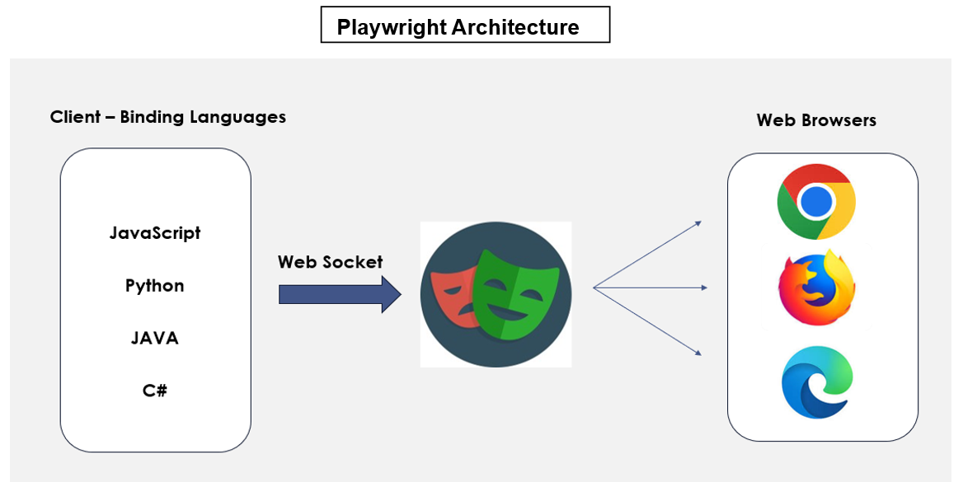
  - There are 3 key components of Playwright Architecture
    - Language binding: Playwright supports multiple programming languages and environments like Java, JavaScript, typescript, python, etc.
    - Web Socket: Playwright uses a web socket protocol to interact with the client and server, in web socket protocol you can send back-to-back requests without terminating the connection which helps Playwright to perform test execution at a much faster pace than other automation tools.
    - Browser Context: It's an isolated instance of a browser that manages its storage, session IDs, cookies, caches, etc. This feature sets apart playwright from other automation tools by enabling the parallel execution of test scripts which speeds up the testing process.
  - Working:
    - firstly, client or language bindings are the programming language that we use to develop the test scripts. As we all know HTTP uses a request-response model with stateless single interactions which means that after each request & response, the connection gets terminated and with each new request a new connection is established between the client and server so it's much slower.
    - Playwrights make use of web sockets instead of HTTP to interact with clients and servers. So once a connection is established between the client and server via web socket protocol, we can send back-to-back requests without terminating the connection which makes it much faster.
    - Once the connection is established test execution starts, and all test cases can use the same connection for their execution, once execution is completed the connection is disabled.
- How auto-wait works internally?
  - Before every action, Playwright verifies:
  - Element attached
  - Visible
  - Stable
  - Enabled
  - Receives events
  - Retries until timeout.
- What is waitForSelector vs Locator auto-wait?
  - waitForSelector() → manual wait
  - Locator → built-in intelligent wait
- What is isolation?
  - Each test gets fresh the
    - Cookies
    - Local storage
    - Session
  - Ensures parallel safety.
- What is Retry logic?
  - retries:2, which Configured in playwright.config.ts
- What causes most flaky tests?
  - Unstable selectors
  - Hard waits
  - Dynamic DOM
  - Shared test data
  - Infra instability
- How to handle flaky tests?
  - Fix root cause
  - Improve selectors
  - Avoid hard waits
  - Enable trace on retry
- How do you detect flaky tests automatically?
  - Run test multiple times in CI and track inconsistent pass rate.
- Should UI tests validate every API response?
  - No, Shift validations to API layer to reduce UI burden.
- What is anti-pattern in Playwright?
  - waitForTimeout()
  - Index-based locators
  - Cross-test dependency
  - Global shared variables
- How do you simulate 500 error in UI?
  - Use page.route() and fulfill with 500 response.
- Where should business logic reside?
  - Inside page/service layer — not inside test files.
- How do you prevent test data collision in parallel?
  - Unique test data generation or worker-based data isolation.
- What is the biggest mistake automation teams make?
  - Over-automating UI instead of building layered strategy.
- How do you decide automation coverage?
  - Risk-based approach: Critical flows, High-frequency features, High-defect areas
- What is automation technical debt?
  - Flaky tests, outdated selectors, poor structure, no reporting.
- What is test sharding in CI?
  - Splitting test suite across multiple machines to reduce execution time.
- How to design framework?
  - Hybrid POM
  - Custom fixtures
  - Env configs
  - Parallel ready
  - Reporting integrated
- Pattern followed?
  - Hybrid pattern which has POM, Fixtures & Utility Layer
- Test data management?
  - JSON files
  - Environment-based
  - Data factories
- What Reusable utilities?
  - Common helpers:
  - Date generator
  - API wrapper
  - Logger
  - Custom assertions
- What is Environment configs?
  - Use .env files and process.env.
- Custom reports?
  - HTML reporter
  - Allure
  - Custom Junit
- Cucumber integration?
  - playwright + cucumber-js
  - Step definitions + hooks
- Convert JSON to JUnit?
  - Custom Node script to transform JSON to XML.
- Which is the best Logging?
  - Winston logger
  - Custom logger utility
  - Log per test file
- How to Reduce 2000 tests execution time?
  - Parallel
  - Sharding
  - API shift
  - StorageState reuse
- How to perform OTP login?
  - Bypass via backend
  - Mock OTP service
  - Use test API
- How to perform Captcha testing?
  - Disable in test env
  - Use backend validation
- Can Playwright tests share session between tests?
  - By default, no (because of isolation).
  - But you can reuse storageState intentionally.
- What happens if you disable test isolation?
  - Testing is risk awareness, Shared cookies/session will be reason for flaky tests, test dependency, parallel conflict.
- How does Playwright support true parallelism?
  - Each test runs in its own browser context and worker process.
- Why does increasing workers sometimes increase failures?
  - Because of Infra awareness, CPU/memory overload, network throttling, shared test data collision.
- When should you use fullyParallel: true?
  - Only when tests are completely independent and data-isolated.
- Why avoid running full regression in all browsers?
  - ROI optimization, Smoke in all browsers, full regression in primary browser.
- How to Measure ROI?
  - Reduced regression time
  - Faster release
  - Reduced manual effort
  - Lower defect leakage
- How to Handle iframe?
  - const frame = page.frameLocator('#iframe');
  - await frame.locator('#btn').click();

